Introduction

Country Y consists of around 89,000 individuals, of which an estimated 32% are under the age of 20 years. The average life expectancy is 62 years, and the population fits a rectangular age distribution.

*Streptolossus Particular* (SP) is responsible for high morbidity, and is endemic in Country Y. Most infections result in severe disease, and individuals are infectious for around 6 days following a latency period of just a few hours. Fortunately, limited access to a single-dose vaccine for SP is now available. The vaccine is believed to give life-long immunity, with a vaccine efficacy of 80%. However, newborns do not receive maternal-derived immunity from either vaccination or previous infection.

The Department of Health for Country Y is interested in introducing a 10 year vaccination schedule to the population in order to determine the best strategy to combat SP Infection. The three strategies in question include vaccination at birth, vaccination at age 20, or a mixed strategy where half of the vaccines go to newborns and the other half to individuals turning 20 years old. However, the Department of Health’s stock is limited to 1200 vaccines a year, so these predications are vital to best ensuring the protection of this population from SP infections and morbidity.

Part 1: Catalytic model

Using serological data from Study P completed two years ago, we built a catalytic model in Excel to estimate transmission parameters. After fitting the observed data of seropositive individuals, we calculated the expected proportions ever infected using the midpoint in each age group (equations 1 and 2; table 4). We used these proportions to estimate a goodness of fit of 0.138 by minimizing the deviance from the model. Assuming the population does not mix randomly, we estimated the force of infections (FOI) for young (0 to 19 years) and old (20 to 62 years) populations separately using Excel’s Solver tool. We also performed a graphical check for constant FOI, finding that there was indeed a difference between the young and old population. The FOI for the young was estimated at 0.04, and 0.02 for the old.

Using the estimated FOIs, we calculated the number of susceptible young and old (equations 3 and 4) at 18733.18 and 18382.16, as well as the average daily number of infections (equations 5 and 6) at 13.05 and 6.16 respectively. We substituted these values using a Who Acquires Infection From Whom (WAIFW) matrix (equation 7) to calculate beta values. Our matrix assumed that young individuals contact each other at a constant rate, β1, and old individuals at constant rate β2, while old individuals contact each other and the young at the same constant rate, β2. We found the effective contact rates β1 = 2.907*10-6 and β2 = 7.52*10-6, which we used to develop a daily contact matrix for the effective contact rates between the young and old (equation 8; figure 7).

We used available demographic information for country Y (N=89,000, Ny=0.32*N), beta values, and duration of infection (D=6) to then estimate an R0 of 1.90 from the Next Generation Matrix (NGM) (equation 9) by calculating the number of infectious individuals in each population resulting from one infectious young or old individual (equations 10 to 13). We then used this R0 estimate to calculate a herd immunity threshold (HIT) of 0.47 (equation 14) suggesting the proportion of the population needing to be immune must meet or exceed 47% in order to stop infectious spread.

Part 2: Mathematical Model

Using our catalytic model estimates, we built an age-dependent deterministic Susceptible-Infectious-Recovered (SIR) model to estimate the effect of different vaccination programs on Country Y (equations 16 to 21). Our model uses the following assumptions: we used age-dependent mixing; all infected individuals become severely sick (100% clinical disease); all infected are infectious for 6 days; we simplified the infection process, including infectiousness beginning within a few hours; newborns have no maternal immunity; no one is immune to infections at the start (t = 0); only 1200 vaccines are available each year; vaccines have 80% efficacy against both infection and disease and provide lifelong immunity; the model is deterministic and unable to represent stochastic effects; we had a continuous population size of 89000, the model deals with fractions of individuals; rates and parameters are constant over time; the model ignores heterogeneities outside age dependent mixing; only old individuals can die or give birth; and only 1 infectious old individual was introduced to the population at the start. Figure 6 shows a diagram of the model we used.

We ran our model for 500 years after introducing 1 infectious old individual to ensure equilibrium simulating the population in Study P. After reaching equilibrium at year 300, we used the first day of year 310 in an unvaccinated population as the baseline, and compared it to the first day of year 310 for each vaccination strategy. Because the model reaches equilibrium by year 300, we observe miniscule differences between year 300 and 310 in the absence of vaccination, and can safely compare results of vaccination after 10 years to the baseline results. Vaccination was introduced at year 300, whereby 1200 single-dose vaccines were given each year at birth (“young strategy”), upon reaching 20 years old (“old strategy”) or a combination where 600 vaccinations went each to newborns and 20 year olds (“mixed strategy”). We vaccinated 85.3% of all newborns (1200/1407) each year in the young strategy, and 80.1% (1200/1499) of all susceptible individuals turning 20 years old each year in the old strategy. For the mixed strategy, we vaccinated 42.6% (600/1407) of births, and 40% (600/1499) of 20 year old individuals each year. All vaccines were assumed to have 80% efficacy.

Table 1 and 2 show our predictions for each strategy. At baseline, we estimate the daily number of new infections per 100,000 people for the young at 5.10 and old people at 1.62. This corresponds with daily new infections of 6.72 per 100,000 for all ages. The force of infection after reaching equilibrium levels off to 7.86*10-5 for the young, and 4.09*10-5 for the old. Finally, the proportion susceptible for the young is 64.8%, and the old is 39.6%, and the proportion immune is 35.1% and 60.4% respectively. For all ages, we expect 47.3% of the population to remain susceptible to infection, and 52.6% to be immune at equilibrium.

We found the young strategy to be most effective at reducing infection over the 10 year period. Within 526 days, we expect to see new infections (figure 1) and the FOI drop to 0. By the end of the program, 50.4% of the young and 42.6% of the old remain susceptible. Overall, 55% of the population will be immune, surpassing the HIT by 8%. Comparably, the old strategy does not prevent all infections, as the number of daily new infections is still 3.95 per 100,000 for all ages by the end of the 10 years (figure 2). Although the mixed strategy does reduce the number of new infections to below 1 within 638 days (figure 3), this value, as well as the FOI, is never expected to actually reach 0. However, this may be because our model uses fractions of individuals and is a limitation of our study.

Overall, table 2 shows the expected number of cases for each of the vaccine strategies. At baseline, after 10 years we expect to see around 50,989 infected individuals. This drops to around 34,847 cases following 10 years of vaccinating 20 year olds. This drops further to around 6272 cases in the mixed strategy. Finally, most effective is the newborn strategy where we expect to see around only 4452 cases before transmission ceases. Figure 5 summarizes the number of cases for each strategy.

When considering the significant decrease in cases when vaccinating newborns, we must bear in mind that the newborn and mixed strategies vaccinate substantial proportions of the 1408 births entering the population each year. And as young individuals age into the old populations, and therefore contribute to old immunity, a sizable portion of newborns are refilling the young population with more immune individuals despite others exiting. Meanwhile, as young are aging out of the population faster than newborns are entering, a demographic shift is occurring whereby the young population is decreasing while the old increases.

Another consideration is that although the total proportion immune and proportion old immune at the end of each strategy exceeds our HIT of 0.47 at the end of 10 years, the proportion immune in the young is 15.9% lower than the HIT in the old strategy, and 10.9% lower in the mixed strategy, but 2.6% higher than the HIT in the newborn strategy (figure 4).

Each of these bring to attention that the contact matrix for this population shows that young individuals come into contact with other young at a much higher rate than other groups (figure 7). It is expected that because vaccination decreases the number of infected, the proportion of young who escape infection until later in life increases. This is particularly noteworthy because the FOI in the young is higher than for the old, so the young are contributing toward new infections more than the old.

Finally, NGMs calculated for each strategy show that the reproduction number decreases to 0.86 in the young strategy, and decreases to 1.00 and 0.99 for the old and mixed strategies respectively (Table 1). While the latter two strategies may be slightly off due to rounding errors, they are close enough to 1 to explain why infection may persist. Meanwhile the reproduction number for the young strategy clearly shows that vaccinating newborns is enough to eliminate infection.

Part 3: BDA model critique

Positive feedback

Overall, Big Data Analytics (BDA) group’s model reaches the correct conclusion. They appropriately include parameters for this population to include births (equal to mortality), and stratify births to enter either the susceptible compartment or recovered compartment based on whether or not they are vaccinated. They also correctly assume that the population size is stable. Similarly, they successfully include parameters to move individuals from susceptible to infection based on a transmission rate (“j”), as well as infectious to recovered based on a recovery rate (“recover”). All parameters are correctly calculated, assuming a randomly-mixing population. Finally, they explored several scenarios to reflect their uncertainty of certain transmission dynamics such as the R0. This uncertainty, while a limitation for studies, is best dealt with through an exploration such as theirs, particularly if their findings report conclusions moving in the same direction.

Negative feedback

The main issue of their study is that they assume random mixing occurs in this population. This is unreasonable, not only by assuming young and old individuals have the same contact patterns, but they build their model in a way which allows children to contribute toward both birth and death. This may be an important distinction for some populations – and frankly may be more realistic – but it complicated the model to the point of skewing the number of people contributing toward and being affected by infections.

Another important limitation of their model is that not all of their equations and values were documented, so it was difficult to determine their reasoning for certain calculations. For instance, we know the average lifespan to be 62 years, yet they use 80 years to calculate the death rate (and by extension the birth rate), thereby decreasing these values. It is also not clear how they calculated their reduction in cases, for instance when using the duration of cases divided by the age of infection multiplies by 50%. Similarly, their reporting of percentage cases prevented in Table B includes calculations not clear to the reader. Finally, it also appears that they chose R0 of 2 and 5 arbitrarily, rather than based on any data.

A final negative part of their report is that their presentation is messy. There is no flow to the report, and it would be impossible to recreate their model given the information they exclude. Other than lambda of 0.037, we don’t know how they calculated their transmission rates, nor how they varied in this model. We also don’t know what software they used to build the model, the timestep, methods, or how they differentiated newborns and 20 year olds when introducing vaccinations.

Comparison to our model

The major agreement between our model and the BDA model is that they both came to the same conclusion of newborn vaccinations having the greatest effect. While we did use some of the same values for parameters – 80% efficacy, 89000 population size, and 6 day infectiousness duration – much of the rest of our models were different. We assumed non-random mixing, and build differential equations for both the young and the old, which also allowed us to build in vaccinations at 20 years old, while their model assumes random mixing, only seems to account for newborn vaccination, and otherwise completely ignores age. Additionally, and likely due to these differences, all our outcomes (including case reduction numbers and R0) were quite different from those estimated by the BDA group.

Part 4: Limitations and Recommendations

There are several limitations to our study. First, a number of our assumption may have had considerable effect on our results, such as our assumptions on demographics and constant rates. Similarly, because our model deals with fractions of individuals, this may explain in part why the mixed strategy never reaches 0, and therefore reintroduces infection quicker than the newborn strategy.

Considering real world applications, our model ignores economic variables and socioeconomic factors. It assumes all families have equal access to vaccines, and doesn’t consider that some families may be less likely to access healthcare services – and by extension the vaccine. Cultural factors likely also affect each strategy. Some parents may not want to vaccinate their newborns with a new vaccine, and would be more comfortable with a vaccination campaign targeting 20 year olds. A newborn strategy also assumes that not only are children born within proximity and access to vaccines, but also that newborns are just as likely to contact children of all ages under 20 years old as they are to be contacted. Our model may have been more accurate if we had used smaller age groups, and would have allowed us to explore other vaccine strategies. In this light, it may be more realistic to assume that school age children have higher contact rates, while younger children generally only contact their parents. It may also be easier (i.e. culturally) and cheaper to implement a school-based vaccination program than to ensure all newborns receive the vaccine.

We recommend that a newborn vaccination strategy be immediately introduced into Country Y. Vaccinating at age 20 does not fully prevent infection, and only reduces cases by 31.7%. The mixed strategy, which reduces cases by 87.7%, only increases the proportion of immune young and old slightly. Meanwhile, the young strategy slightly decreases the proportion of immune old, but greatly increases the number of immune young (figure 4). This is important because the young are known to contact other young at a higher rate, therefore higher immunity in that group protects the whole population.

Our main recommendation for further work is to explore the effect of vaccination over longer periods. Although the newborn strategy quickly reduces the number of new infections to 0, it would be important to know whether this actually eliminates the disease, or if infections will return once enough individuals are susceptible again. In our SIR model, we noticed that once newborn vaccinations ceased, the number of susceptible old continued to rise while susceptible young immediately reversed its trend and rose quickly to the point that an outbreak occurred within 15 years, followed by increasingly regular outbreaks as the population reapproaches equilibrium over the next 275 years.

Economic analysis should also be carried out to determine feasibility of these strategies and their cost effectiveness. While it is theoretically easy to vaccinate children as they are born – particularly if born in proximity to health centers - it may be more cost effective to have a yearly campaign targeting children in schools. Finally, this work should be repeated in other countries to determine which variables are constant, and how these strategies affect other populations. If findings are consistent, there may be greater regional or global interest to share resources and increase the scale of vaccinations, therefore further decreasing the burden of disease.

Table 1. Summary of predictions of the proportions of young (0 to 19) and old (20 to 62) individuals that are susceptible following 10 years of vaccination of newborn, 20 year olds, or a combined strategy; these population’s Next Generation Matrices, and reproduction numbers. *R0; ηProportion susceptible in young; μProportion susceptible in old

|  |  |  |  |  |  |
| --- | --- | --- | --- | --- | --- |
| Vaccination Strategy | Number of Susceptibles (%) | | Next Generation Matrix | | Rn |
| Young (<20) (ny= 28,480) | Old (≥20) (no=60,519) |
| No vaccination | 17345.8642 (64.8%)η | 23964.15558 (39.6%)μ | 1.29 | 0.50 | 1.90* |
| 1.06 | 1.06 |
| Vaccination at birth | 13469.66904 (50.4%)η | 25784.51145 (42.6%)μ | 0.61 | 0.24 | 0.86 |
| 0.45 | 0.45 |
| Vaccination at 20 years | 18427.98488 (68.9%)η | 20046.06767 (33.1%)μ | 0.83 | 0.32 | 1.00 |
| 0.35 | 0.35 |
| Mixed strategy | 17091.87585 (63.9%)η | 24061.92429 (39.8%)μ | 0.77 | 0.30 | 0.99 |
| 0.42 | 0.42 |

Table 2: Summary of predictions of the average daily force of infection for young and old and the number of new infections per 100,000 in the young, old and total populations following the introduction of vaccination strategy in newborns, 20 year olds, or a combined strategy.

|  |  |  |  |  |  |
| --- | --- | --- | --- | --- | --- |
|  | No vaccination | Vaccination at birth | Vaccination at 20 years | Mixed strategy | |
| Percentage vaccinated | 0% | 85.3% | 80.1% | Y=42.6% | O=40% |
| Daily new infections per 100,000 people |  |  |  |  | |
| Young | 5.10 | 0 | 3.20 | 1.65*10-4 | |
| Old | 1.62 | 0 | 0.76 | 5.37*10-5 | |
| All | 6.72 | 0 | 3.95 | 2.19*10-4 | |
| Daily force of Infection |  |  |  |  | |
| Young | 7.86*10-5 | 0 | 4.64*10-5 | 0 | |
| Old | 4.09*10-5 | 0 | 2.29*10-5 | 0 | |
| Total number of Cases | 50989.2796 | 4452.20802 | 34847.1603 | 6272.60074 | |

Figure 1: Daily new infections per 100,000 after vaccinating 85.3% of newborns for 10 years. Young new infections in black; old new infections in orange; new infections for all ages in blue.

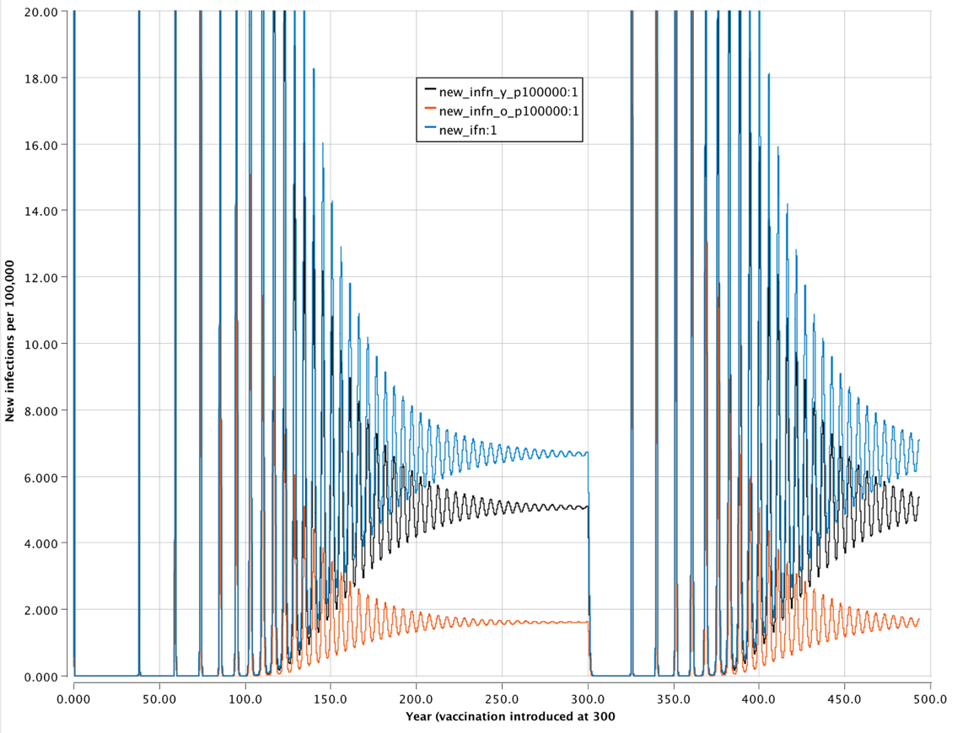

Figure 2: Daily new infections per 100,000 after vaccinating 80.1% of 20 year old individuals for 10 years. Young new infections in black; old new infections in orange; new infections for all ages in blue.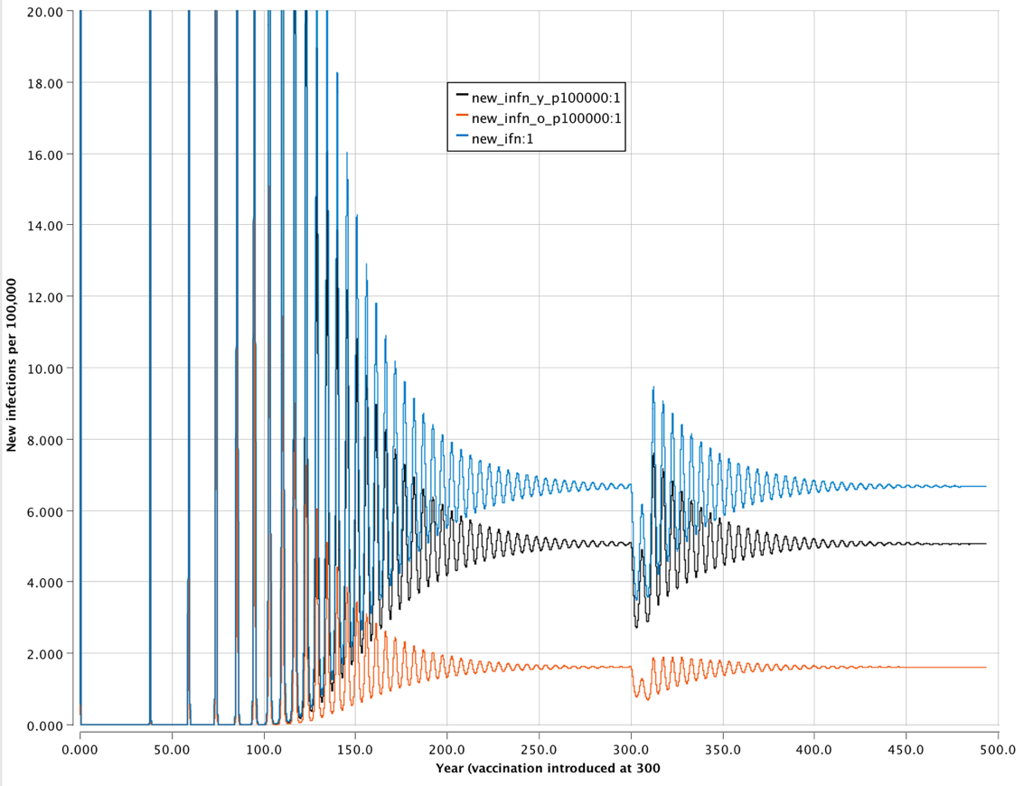

Figure 3: Daily new infections per 100,000 after vaccinating 42.6% of newborns and 40% of 20 year old individuals for 10 years. Young new infections in black; old new infections in orange; new infections for all ages in blue.

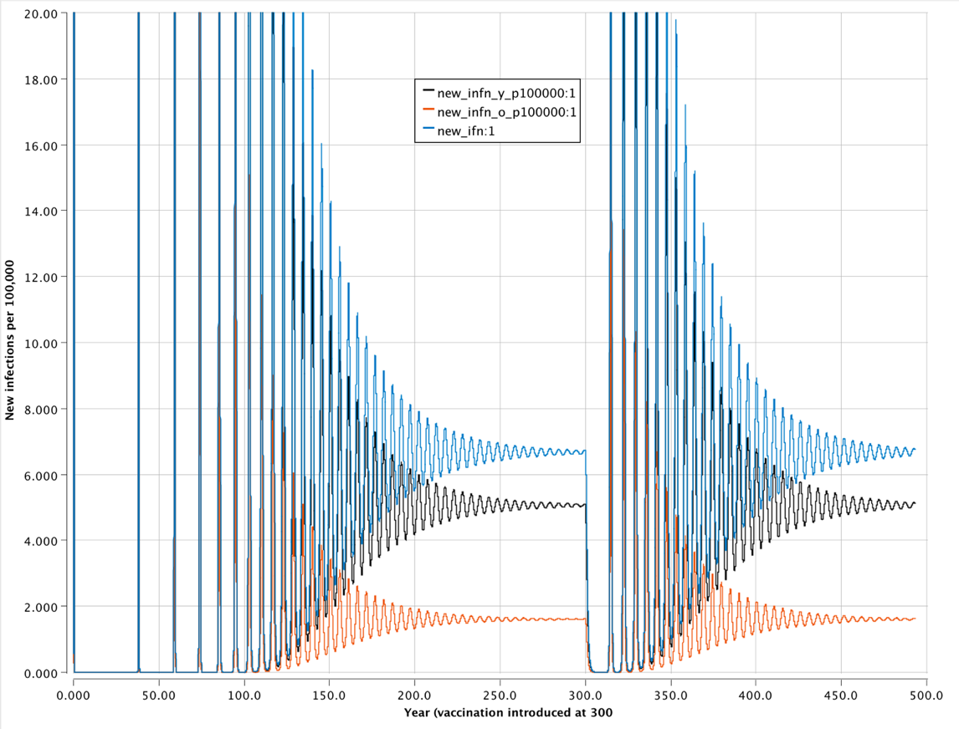

Figure 4: Proportion of young (0 to 19 years), old (20 to 62 years), and total population that are immune to infection compared to the Herd Immunity Threshold after vaccinating 85.3% of newborns for 10 years. Young immune in red; old immune in blue; total immune in green; herd immunity threshold in purple.

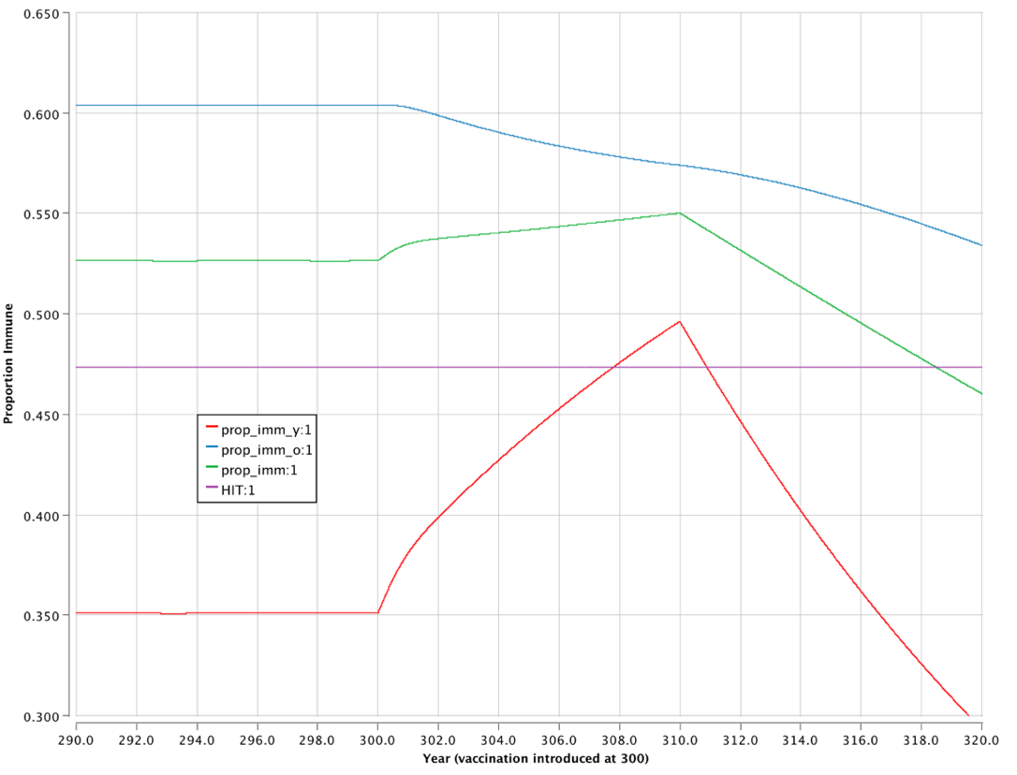

Figure 5: Number of cases over 10 years predicted for each vaccination strategies.



**Technical Appendix**

Equations

Eqn 1: Expected prop. young ever infected: $s\left(<20\right)=1-\exp\left(-λ_{y}a\right)$

Eqn 2: Expected prop. old ever infected: $s\left(≥20\right)=1-(\exp\left(-20λ_{y}\right)\exp\left(-λ_{o}\left(a-20\right)\right)$

Eqn 3: Number of susceptible young individuals: $S_{y}=\frac{N*(1-exp⁡(-19*λ_{y})}{62*λ_{y}}$

Eqn 4: Number of susceptible old individuals: $S_{o}=\frac{N*\exp\left(-19*λ_{y}\right)*(1-exp⁡(\left(62-19\right)-λ_{o})}{62*λ_{o}}$

Eqn 5: Average daily number of infections (young): $I_{y}=λ_{y}{*S}_{y}*\frac{D}{365}$

Eqn 6: Average daily number of infections (old): $I_{o}=λ_{o}{*S}_{o}*\frac{D}{365}$

Eqn 7: WAIFW matrix: $\left(\frac{λ_{y}}{λ_{o}}\right) = \left(\frac{β_{1 }β_{2}}{β_{2} { β}_{2}}\right)\left(\frac{I_{y}}{I_{o}}\right)$

Eqn 8: Daily contact matrix: $\left[\frac{β_{yy}{ β}_{yo}}{β_{oy}{ β}_{oo}}\right]= \left[\frac{2.91*{10}^{-6} 7.52*{10}^{-6}}{7.52*{10}^{-6} 7.52*{10}^{-6}}\right]$

Eqn 9: Next Generation Matrix: $\left[\frac{R_{yy} { R}_{yo}}{R_{oy} { R}_{oo}}\right]= \left[\frac{1.29 0.50}{1.06 1.06}\right]$

Eqn 10: $R_{yy}=β_{yy}S_{y}D$

Eqn 11: $R_{yo}=β_{yo}S_{y}D$

Eqn 12: $R_{oy}=β_{oy}S_{o}D$

Eqn 13: $R_{oo}=β_{oo}S_{o}D$

Eqn 14: Herd immunity threshold: $HIT= 1-\frac{1}{R_{0}}$

Eqn 15: proportion immune in order to terminate outbreak: $1-HIT=1-(\frac{1}{R_{0}})$

Differential Equations for the Young

Eqn 16: Young susceptibles: $\frac{dS_{y}(t)}{dt}= -S_{y}(t)*λ_{y}-S_{y}(t)*a+B*\left(1-{VC}_{y}*VE\right)$

Eqn 17: Young infectious: $\frac{dI_{y}(t)}{dt}= +S_{y}\left(t\right)*λ_{y}-I_{y}\left(t\right)*r-I_{y}\left(t\right)*a$

Eqn 18: Young recovered $\frac{dR_{y}(t)}{dt}= +I_{y}\left(t\right)*r-R_{y}\left(t\right)*a+B*\left({VC}_{y}*VE\right)$

Differential Equations for the Old

Eqn 19: Old susceptibles: $\frac{dS_{o}(t)}{dt}= -S_{o}\left(t\right)*λ_{o}-S_{o}\left(t\right)*m+S_{y}\left(t\right)*a*\left(1-{VC}_{o}*VE\right)$

Eqn 20: Old infectious $\frac{dI_{o}(t)}{dt}= +S_{o}\left(t\right)*λ_{o}-I_{o}\left(t\right)*r+I_{y}\left(t\right)*a-I_{o}\left(t\right)*m$

Eqn 21: Old recovered: $\frac{dR_{o}(t)}{dt}= +I_{o}\left(t\right)*r-R_{o}\left(t\right)*m+R_{y}\left(t\right)*a+S_{y}\left(t\right)*a*\left({VC}_{o}*VE\right)$

TABLE 3: Initial Values and model setup

|  |  |
| --- | --- |
| Parameter | Value |
| Number of susceptible young at the start (Sy0) | 28480 |
| Number of susceptible old at the start (So0) | 60519 |
| Number of infectious young at the start (Iy0) | 0 |
| Number of infectious old at the start (Io0) | 1 |
| Number of immune young at the start Ry(0) | 0 |
| Number of immune old at the start Ro(0) | 0 |
| Modeling method | Runge-Kutta 4 |
| Time step | 1.0 |

Table 4: Catalytic model, results of Study P, contribution to loglikelihood

|  |  |  |  |  |  |  |  |
| --- | --- | --- | --- | --- | --- | --- | --- |
| Age (years) | Number | | | Proportion positive | Expected proportion ever infected | Contribution to loglikelihood | |
| Positive | Negative | Total | Saturated | Catalytic |
| 0 |  |  |  | 0 |  |  |  |
| 1 to 4 | 11 | 102 | 113 | 0.0973 | 0.1005 | -36.0707 | -36.0770 |
| 5 to 9 | 27 | 76 | 103 | 0.2621 | 0.2566 | -59.2537 | -59.2618 |
| 10 to 19 | 21 | 26 | 47 | 0.4468 | 0.4590 | -32.3114 | -32.3255 |
| 20 to 29 | 19 | 12 | 31 | 0.6129 | 0.6090 | -20.6903 | -20.6913 |
| 30 to 39 | 42 | 19 | 61 | 0.6885 | 0.6810 | -37.8368 | -37.8446 |
| 40 to 49 | 32 | 12 | 44 | 0.7272 | 0.7398 | -25.7819 | -25.7998 |
| 50 to 59 | 24 | 6 | 30 | 0.8 | 0.7878 | -15.0120 | -15.02555 |

Table 5: Model Parameters.

|  |  |  |  |
| --- | --- | --- | --- |
| Symbol | Definition | Value/equation | Justification |
| λy | Force of infection in young | *β1*Iy + β2*Io* | Estimated using Study P |
| λo | Force of infection in old | *β2*Iy + β2*Io* | Estimated using Study P |
| B | Births | *(Po)*m* | Birthrate is the same as deaths |
| m | Mortality rate | *1/(ADo*365)* | Rate at which old die |
| a | Age rate in the young | *1/(ADy*365)* | Rate at which young become old |
| r | Recovery rate | *1/D* | Rate at which old individuals die |
| VE | Vaccine efficacy | 0.8 | Proportion of successful vaccinations |
| VCy | Vaccine coverage in young | Varies: 0.853 for the young strategy; 0.426 for the mixed strategy | Estimates the vaccine strategy for young group |
| VCo | Vaccine coverage in old | Varies: 0.801 for the young strategy; 0.4 for the mixed strategy | Estimates the vaccine strategy for old group |
| β1 | Beta 1 | 7.52E-06 | Estimated from Study P |
| β2 | Beta 2 | 2.91E-06 | Estimated from Study P |
| L | Life expectancy | 62 | Life expectancy for Country Y |
| N | Total population | 89000 | Total population for Country Y |
| Py | Population young | 28480 | Total young for Country Y |
| Po | Population old | 60520 | Total old for Country Y |
| ADy | Average duration young (years) | 19 | Average time spent in young group |
| ADo | Average duration old (years) | 43 | Average time spent in young group |
| D | Average duration infectious (days) | 6 | Average time spent infectious |
| Sy | Susceptible young | Varies | Model compartment |
| So | Susceptible old | Varies | Model compartment |
| Iy | Infectious young | Varies | Model compartment |
| Io | Infectious old | Varies | Model compartment |
| Ry | Immune young | Varies | Model compartment |
| Ro | Immune old | Varies | Model compartment |
| (t) | Timestep | DT = 1 | Daily timestep |

Figure 6: Diagram of SIR model describing transmission dynamics for *Streptolossus Particular* for young and old populations in Country Y. Parameters next to arrows represent the rate at which individuals move from one category to the next.



Figure 6: Catalytic model comparing observed and expected proportion seropositive for *Streptolossus Particular* of Country Y based on Study P.



Figure 7: Summary of WAIFW matrix for young and old individuals estimated for Country Y from Study P.

